
Request for Proposal (RFP)
2024 Lakeview East
SSA #8 Landscaping

SCOPE OF WORK: Landscaping installation of plants and maintenance for all of SSA#8 planters. Boundaries include 2800-3800 N. Broadway; 2800-3200 N. Clark; 2800-3200N. Halsted and 400-800 N. Diversey
Planters and maintenance for:
(11) 36” Round Planters
Spring /Summer 2024: Remove and dispose of existing planter materials: Recondition top – soil in planter: Gypsum, Osmokote (3-month slow-release fertilizer); peat moss. Installation of Spring and summer material
Winter 2024: Remove and dispose of existing planter materials: Recondition top – soil in planter: Gypsum, Osmokote (3-month slow-release fertilizer), Peat moss.

(7) 60” Round Planters
Spring /Summer 2024: Remove and dispose of existing planter materials: Recondition top – soil in planter: Gypsum, Osmokote (3-month slow-release fertilizer); peat moss. Installation of Spring and summer material
Winter 2024: Remove and dispose of existing planter materials: Recondition top – soil in planter: Gypsum, Osmokote (3-month slow-release fertilizer), Peat moss.

(28) 74” x 36” Rectangular Planters
Spring /Summer 2024: Remove and dispose of existing planter materials: Recondition top – soil in planter: Gypsum, Osmokote (3-month slow-release fertilizer); peat moss. Installation of Spring and summer material
Winter 2024: Remove and dispose of existing planter materials: Recondition top – soil in planter: Gypsum, Osmokote (3-month slow-release fertilizer), Peat moss.

(80) Hanging Baskets on Broadway Ave
Spring /Summer 2024: Remove and dispose of existing planter materials: Recondition top – soil in planter: Gypsum, Osmokote (3-month slow-release fertilizer); peat moss. Installation of Spring and summer material
Winter 2024: Remove and dispose of existing planter materials: Recondition top – soil in planter: Gypsum, Osmokote (3-month slow-release fertilizer), Peat moss.

(28) Hanging Baskets on Clark St
Spring /Summer 2024: Remove and dispose of existing planter materials: Recondition top – soil in planter: Gypsum, Osmokote (3-month slow-release fertilizer); peat moss. Installation of Spring and summer material
Winter 2024: Remove and dispose of existing planter materials: Recondition top – soil in planter: Gypsum, Osmokote (3-month slow-release fertilizer), Peat moss.

(3) 46” Round Planters
Spring /Summer 2024: Remove and dispose of existing planter materials: Recondition top – soil in planter: Gypsum, Osmokote (3-month slow-release fertilizer); peat moss. Installation of Spring and Summer material
Winter 2024: Remove and dispose of existing planter materials: Recondition top – soil in planter: Gypsum, Osmokote (3-month slow-release fertilizer), Peat moss.

Maintenance and Watering June – October 2024
Landscape parklet for Art Festival – September 14-15
Landscaper will commit to sponsor and install a landscape oasis at the annual Lakeview East Festival of the Arts September 14-15th, 2024. Area: 3420-3434 N. Broadway. Lanscaper will work with Arts Committee to creat the annual parklet in the street. Approximately: 250 ft L x 40 ft wide. Landscaper will also be responsible for installation and take down during assigned times and will abide by festival schedule.

Example of landscape oasis:
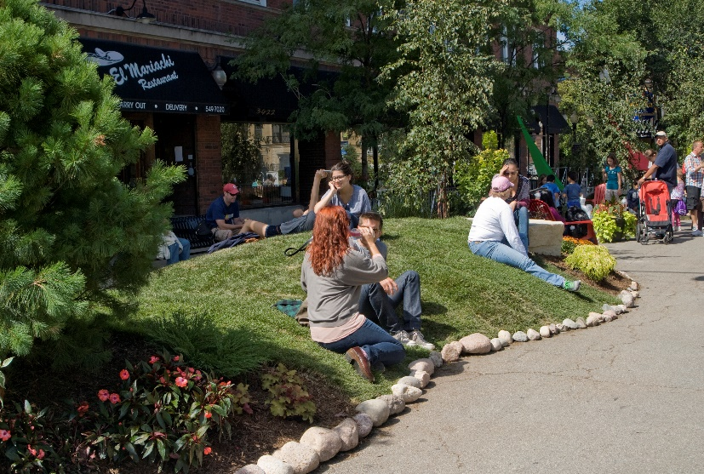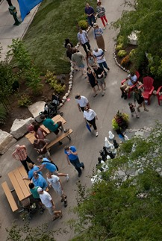

SSA MAP FOR PLANTERS:

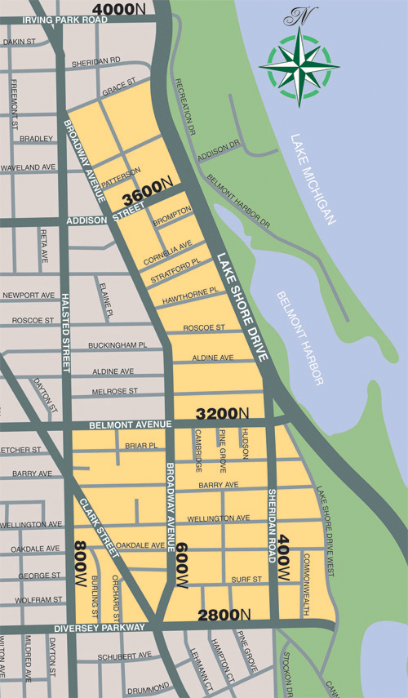

Period of Contract: March 1, 2024 – December 31, 2024
Proposal Submission: Interested parties are invited to submit a detailed proposal outlining their approach, experience, and relevant qualifications by January 15, 2024.
Contact Information: For inquiries and proposal submission, please contact: Nata Wier, Associate Director, Lakeview East Chamber of Commerce.
We look forward to receiving your proposal.
Sincerely,
Nata Wier
nata@lakevieweast.com
773-348-8608

